Assignment 1 (50pts)
Menu Page with Date Stamp

DUE: 01/31/20

Directions:

1. Construct a menu page which includes JavaScript code. This page will serve as your homepage for this class. It will include a list of links to the assignments you complete.
2. Include JavaScript code to display the date at the bottom of the page.
3. Upload your page to the CRC web server (see Presentation 1d for details).

• Be sure to include your name and the class info at the top of the page.
• Refer to Help Presentation A1 to see an example of this assignment completed.

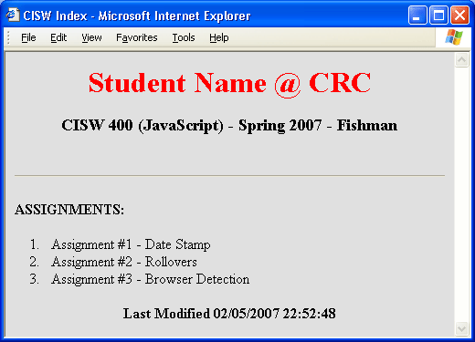

Date Stamp:
Include the following JavaScript code within your HTML, to display time and date*

<script language=”javaScript”>
document.write(document.lastModified);
</script>

* If you cut and paste, you may need to check syntax carefully.

What to turn in:

- Upload your file to the CRC Web Server and send me an email containing the URL.

- Entitle the message subject heading CISW400 Assignment 1 and include your full name in the message body, along with the URL.

INSTRUCTOR’S EMAIL ADDRESS: fishmaw@crc.losrios.edu

